Playlist for 4-5 Killer Projects for SDE-III
💣 KILLER PROJECTS MASTER PLAYLIST
(Microservices + AWS + System Design + Scale)
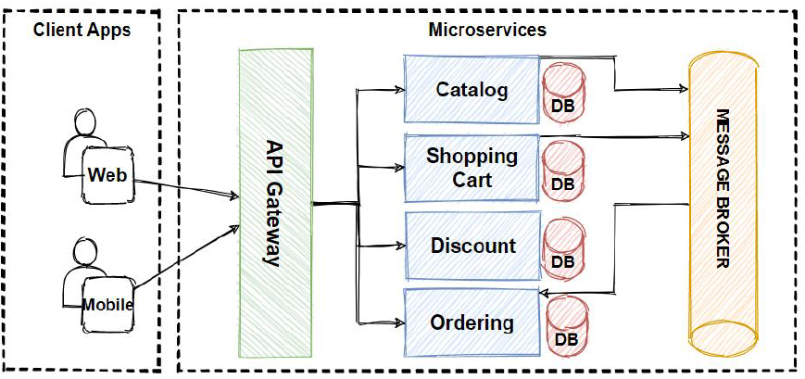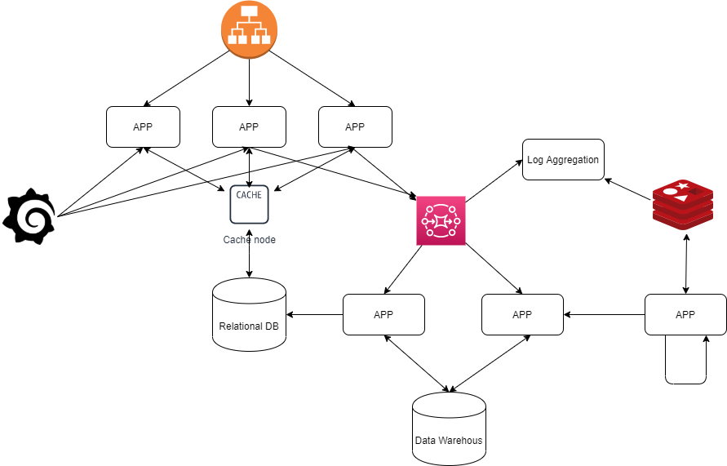

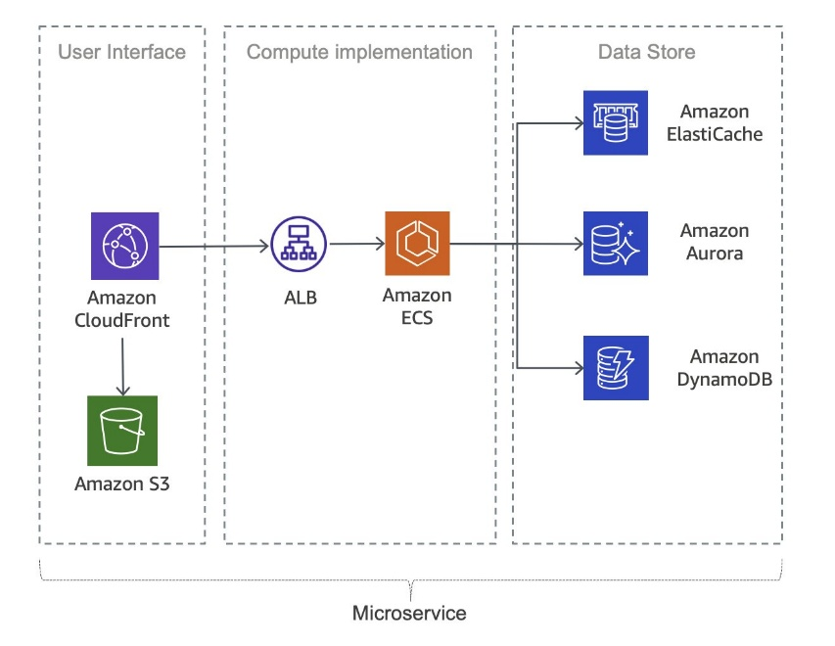

🧱 PROJECT FOUNDATION (Week 0 – Mandatory Setup)
Before starting any project
Videos (2–3 long videos)
1️⃣ How to design a project like FAANG engineers
2️⃣ How to write Architecture README (VERY IMPORTANT)
3️⃣ How interviewers evaluate projects (truth)
📌 Deliverables for every project
- Architecture diagram
- API contracts
- DB schema
- Scaling strategy
- Failure scenarios
- AWS deployment diagram

🧨 PROJECT 1 — E-COMMERCE MICROSERVICES SYSTEM (FLAGSHIP)
(This alone can crack SDE-III if done well)
⏱ Duration: 25–30 days
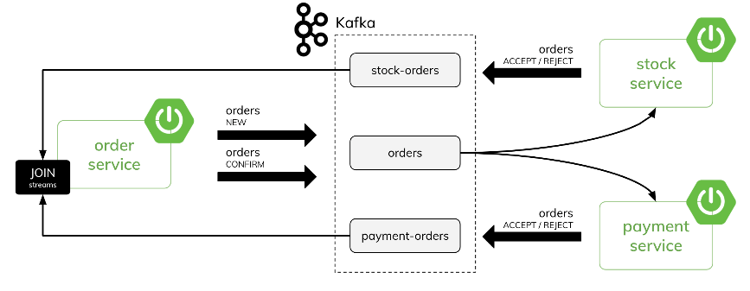
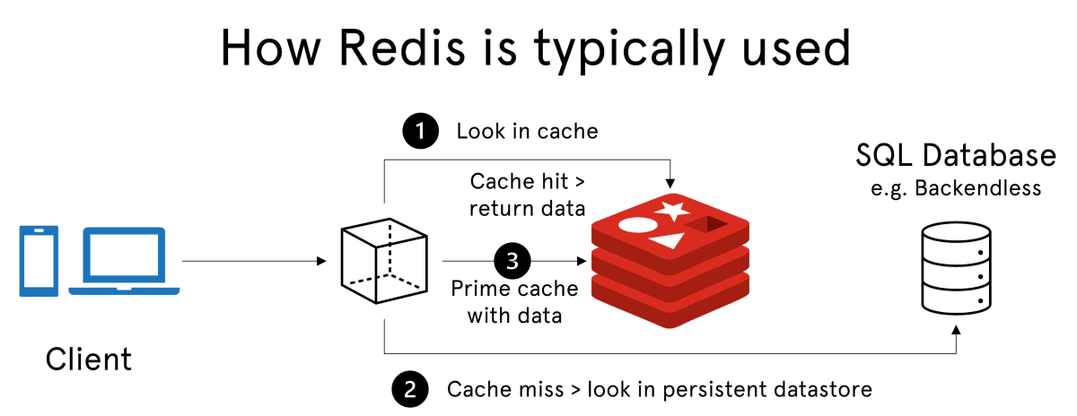

🔹 Phase 1 — System Design First (Day 1–4)
🎯 Think before coding (this is what seniors do)
Day 1
▶ Requirements (functional + non-functional)
▶ Traffic estimation
▶ APIs definition
Day 2
▶ Service decomposition
- User
- Product
- Cart
- Order
- Payment
- Inventory
Day 3
▶ Database design (MySQL schemas)
▶ Redis caching strategy
Day 4
▶ Event-driven flow (Kafka)
▶ Failure & retry design
📌 Interview Gold:
“Why is Cart separate from Order?”

🔹 Phase 2 — Core Microservices (Day 5–14)
Day 5–6 — User Service
- JWT auth
- Roles
- User lifecycle
Day 7–8 — Product Service
- Product catalog
- Redis cache (read-heavy)
- Cache invalidation
Day 9–10 — Cart Service
- Redis-backed cart
- TTL-based expiry
- Session handling
Day 11–12 — Order Service
- Order creation
- Order state machine
- Idempotency
Day 13–14 — Inventory Service
- Stock reservation
- Race condition handling
- Consistency trade-offs

🔹 Phase 3 — Payment + Kafka (Day 15–18)
Day 15
▶ Payment Service design
▶ External payment simulation
Day 16
▶ Kafka setup
▶ Order → Payment events
Day 17
▶ Exactly-once intuition
▶ DLQ handling
Day 18
▶ Failure recovery demo

🔹 Phase 4 — AWS Deployment (Day 19–24)
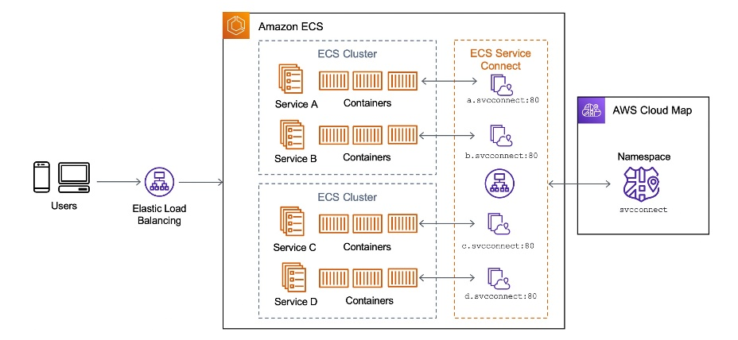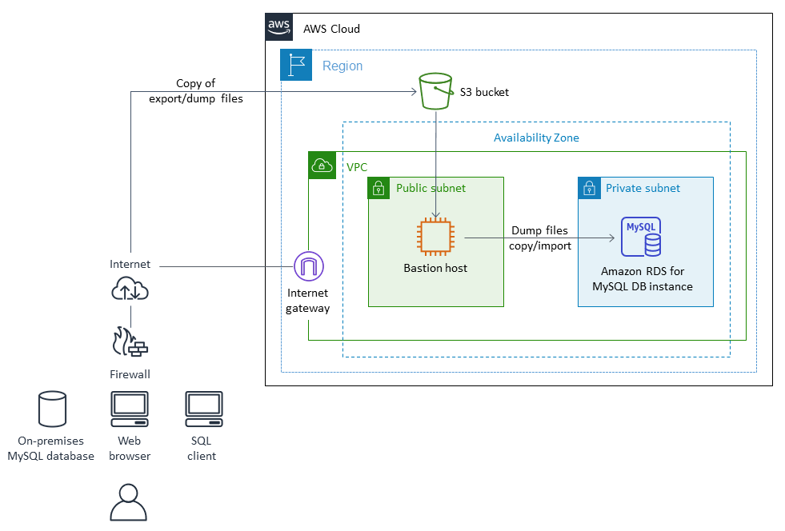

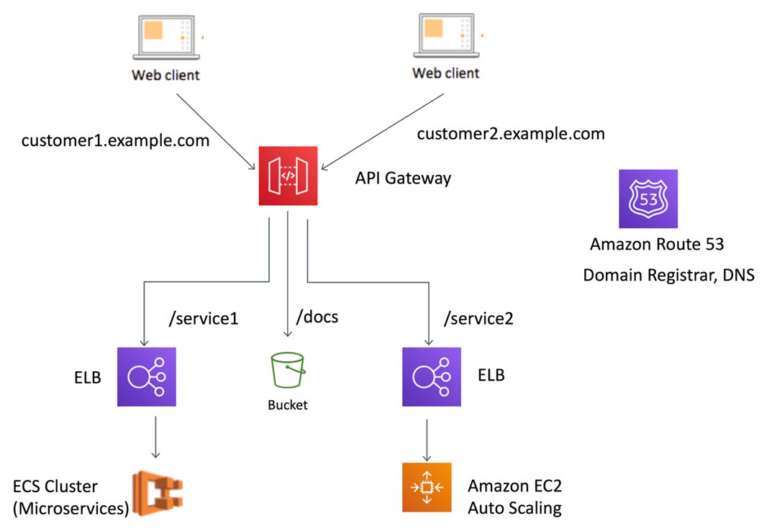
Day 19
▶ Dockerize all services
Day 20
▶ Push images to ECR
Day 21
▶ Deploy services on ECS
Day 22
▶ API Gateway routing
Day 23
▶ RDS + S3 integration
Day 24
▶ Scaling demo + CloudWatch

🔹 Phase 5 — Interview Layer (Day 25–27)
▶ System design explanation (45 min mock)
▶ Bottlenecks & fixes
▶ Resume explanation
✅ Why this project works
✔ Massive architecture
✔ Event-driven
✔ AWS + Microservices
✔ Exactly what FAANG expects

🧨 PROJECT 2 — REAL-TIME CHAT APPLICATION
(Concurrency + real-time = senior signal)
⏱ Duration: 15–18 days
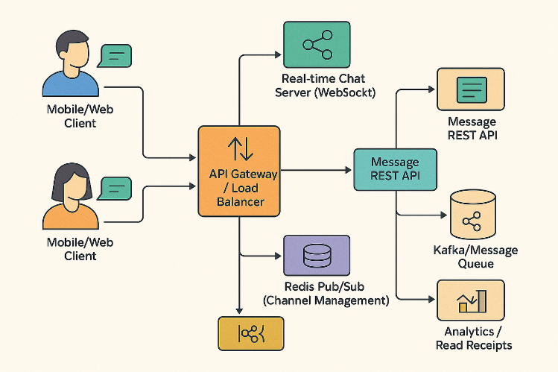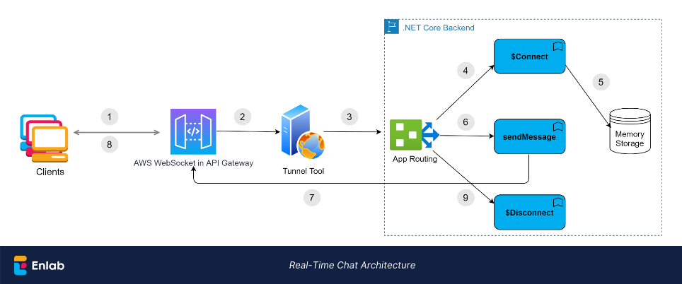

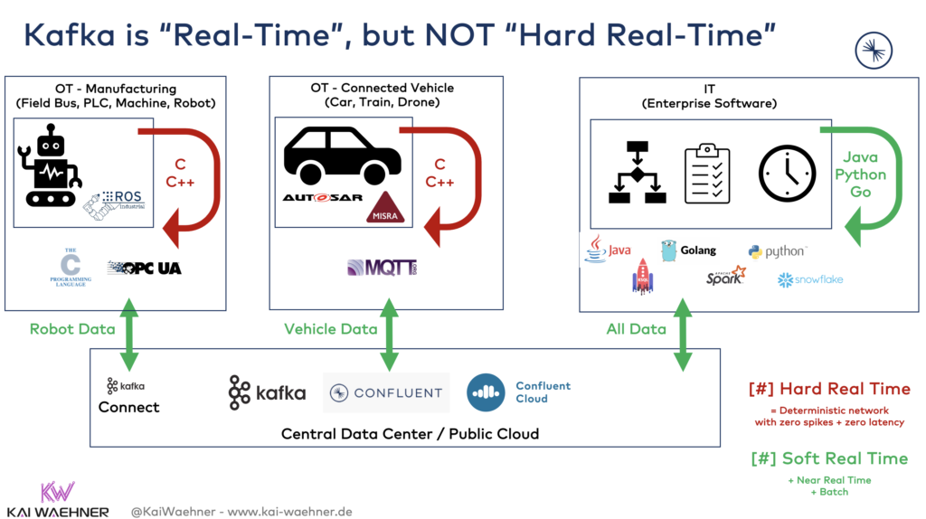

🔹 Phase 1 — Design (Day 1–3)
- WebSocket vs HTTP
- Message delivery guarantees
- Online/offline handling

🔹 Phase 2 — Core Features (Day 4–10)
- WebSocket server
- One-to-one chat
- Typing indicators
- Redis user presence
- Kafka message stream

🔹 Phase 3 — Scale & AWS (Day 11–15)
- Horizontal scaling WebSocket
- Sticky sessions
- Redis cluster
- Deploy on AWS ECS

🔹 Phase 4 — Interview Mapping (Day 16–18)
- Message ordering
- Fan-out strategies
- Failure handling
✅ Why interviewers love this
✔ Concurrency
✔ Real-time
✔ Messaging
✔ Harder than CRUD

🧨 PROJECT 3 — URL SHORTENER (OR FEED SYSTEM)
(Pure System Design power)
⏱ Duration: 10–12 days
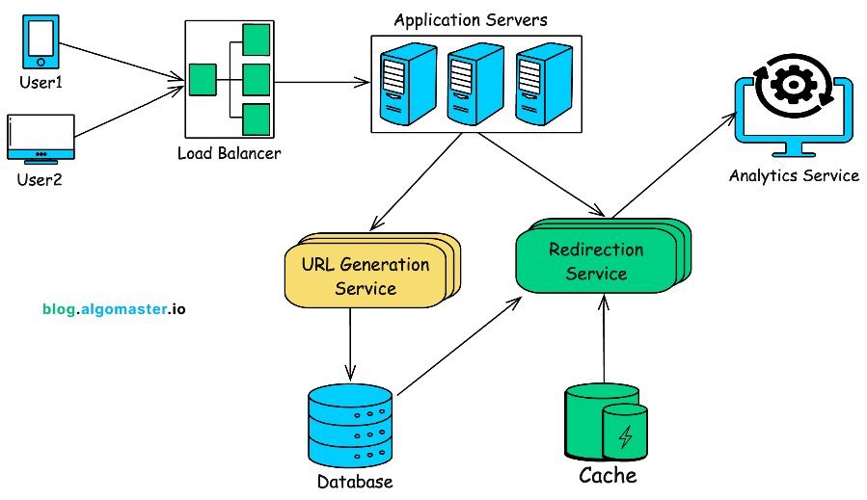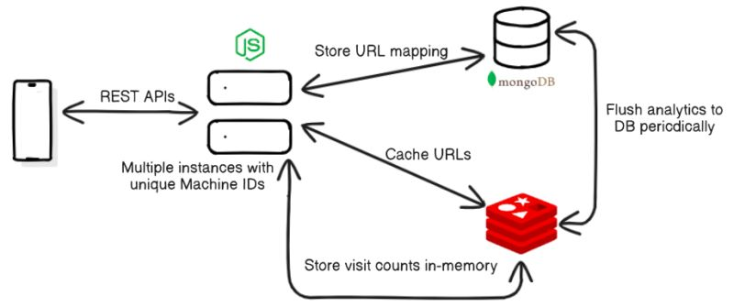

🔹 URL SHORTENER FLOW
- Base62 hashing
- Redis cache
- MySQL persistence
- Load balancing
- Read-heavy optimization
📌 OR
🔹 NEWS FEED SYSTEM (Advanced Option)
- Fan-out on write
- Feed cache
- Follower graph
- Timeline generation

🧨 PROJECT 4 (OPTIONAL BONUS) — RATE LIMITER / ANALYTICS
⏱ Duration: 5–7 days
- Token bucket
- Sliding window
- Redis-based counters
- Used as reusable infra service

🏆 FINAL PROJECT COUNT
Project | Complexity
E-Commerce | ⭐⭐⭐⭐⭐
Chat System | ⭐⭐⭐⭐
URL / Feed | ⭐⭐⭐⭐
Infra Tool | ⭐⭐⭐
👉 4 strong projects = SDE-III ready
👉 5 projects = Architect mindset

